**Assignment No. 3**

Name: Hagit Shaposhnik

ID: 037650009

**Part 1 – Aim: ANN from Scratch**

The following “compare changes” presents the changes that was made to add a 2nd layer to the supplied code.

***Helper functions***

Modification in *compute_mse_and_acc*

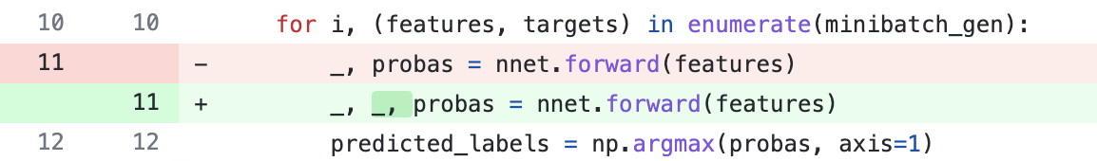

Line 11. The _ variable represents the output layer ( _, _ represents 2 layers).

Modification in *Train*

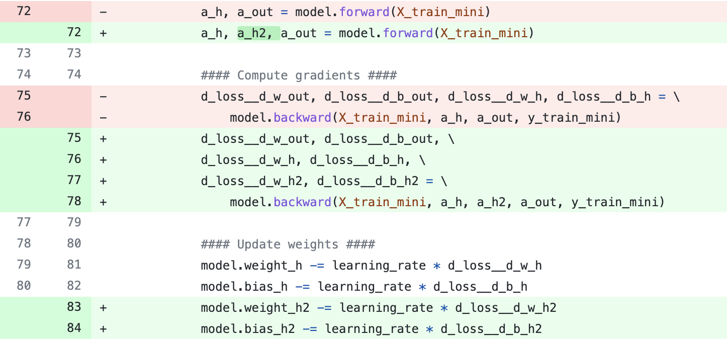

Line 72. The *ah* variable represents the output layer (*ah, ah* _ represents 2 layers).

Lines 75-78. The backward function returns the loss also for the 2nd layer.

Line 83-84. Adjust the weight and bias of the 2nd layer by using the 2nd layer loss value.

***NeuralNetMLP Class***

Modification in *class init*

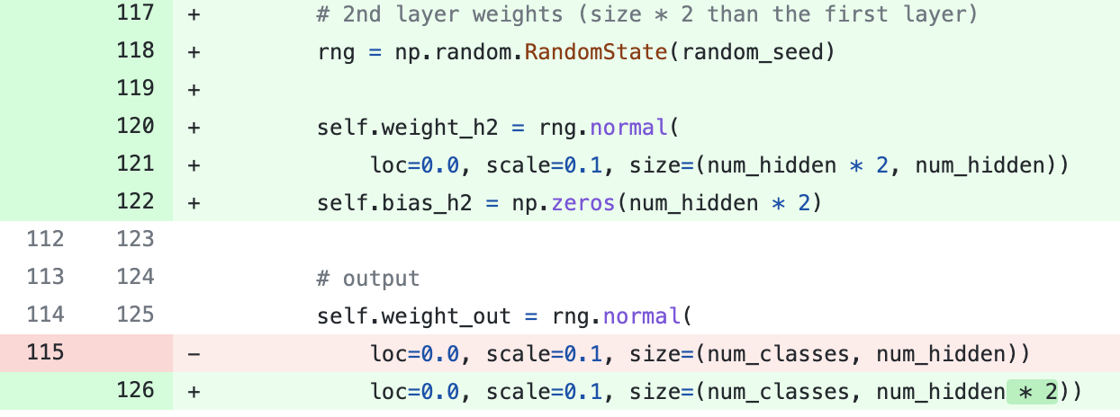

Line 117-122. Adding 2nd layer weight and bias initiate with random values, the 2nd layer size is twice the size of the 1st layer.

Line 126. Changing the output weight, the input of the last layer switched to the output of the 2nd layer. Thus, the input size is twice the size it was before.

Modification in *foward*

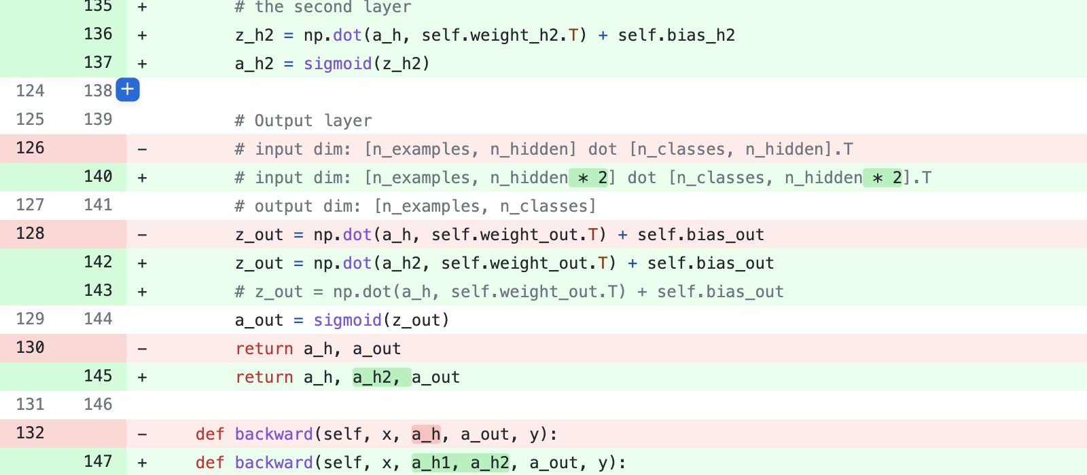

Lines 136-137. The output of the 1st layer goes through the 2nd layer.

Lines 140-142. The input of the output layer is the 2nd layer output.

Line 145. Return the output of the 2nd layer.

Modification in *backward*

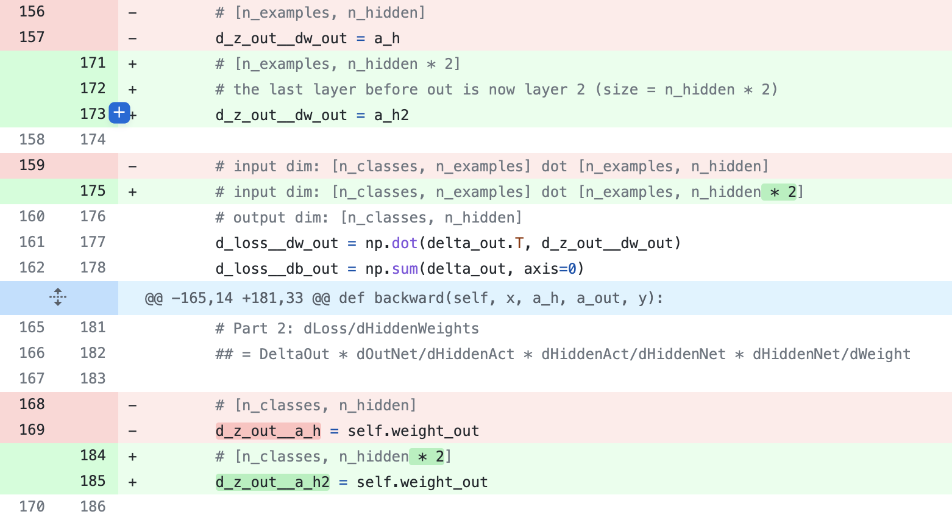

Line 173. The input of the output layer is the 2nd layer output. (Set variable to 2nd layer output)

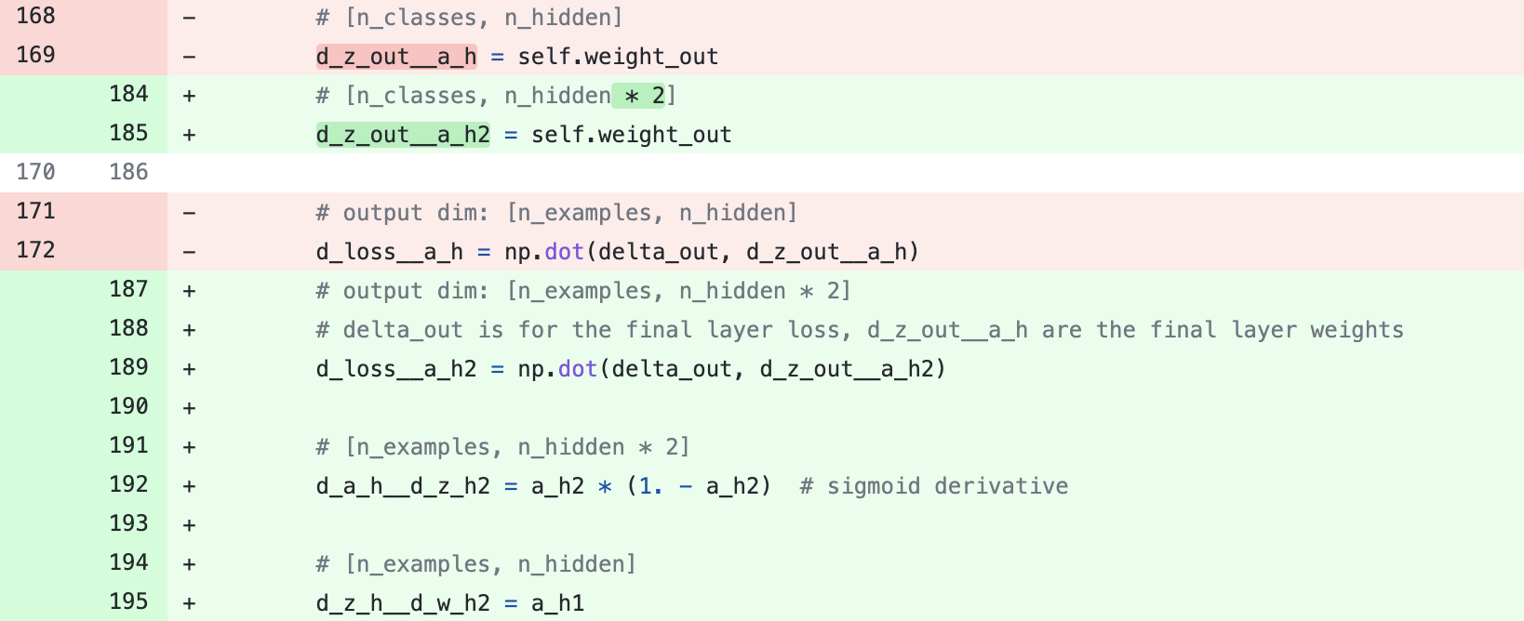

Line 185. The input of the output layer is the 2nd layer output. (Set variable to output weight).

Line 189. Calculates the loss result from the 2nd layer.

Line 192. Calculate the sigmoid on the 2nd layer.

Line 195. Set variable to 1st layer output

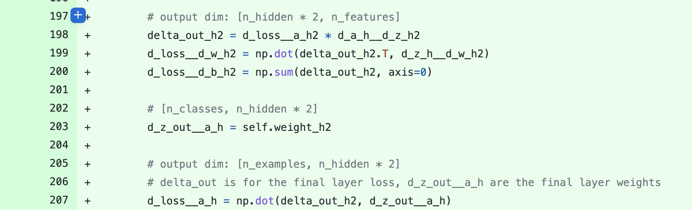

Lines 198-200. Calculates the loss for the 2nd layer.

Line 203. Set variable to the weight of the 2nd layer (The layer after the 1st layer)

Line 207. Calculate the loss result from the 1st layer.

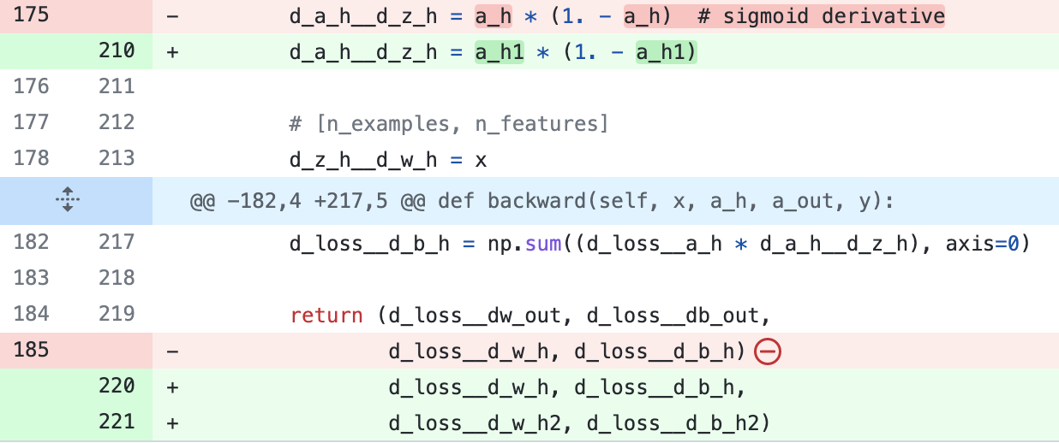

Line 210. Calculates the sigmoid on the 1st layer.

Lines 220-221. Returns the loss for the 2nd layer.

**Part 2- Aim: Practice the usage of CNN (Convolutional Neural Network).**

To understand the data, I used the Orange3™

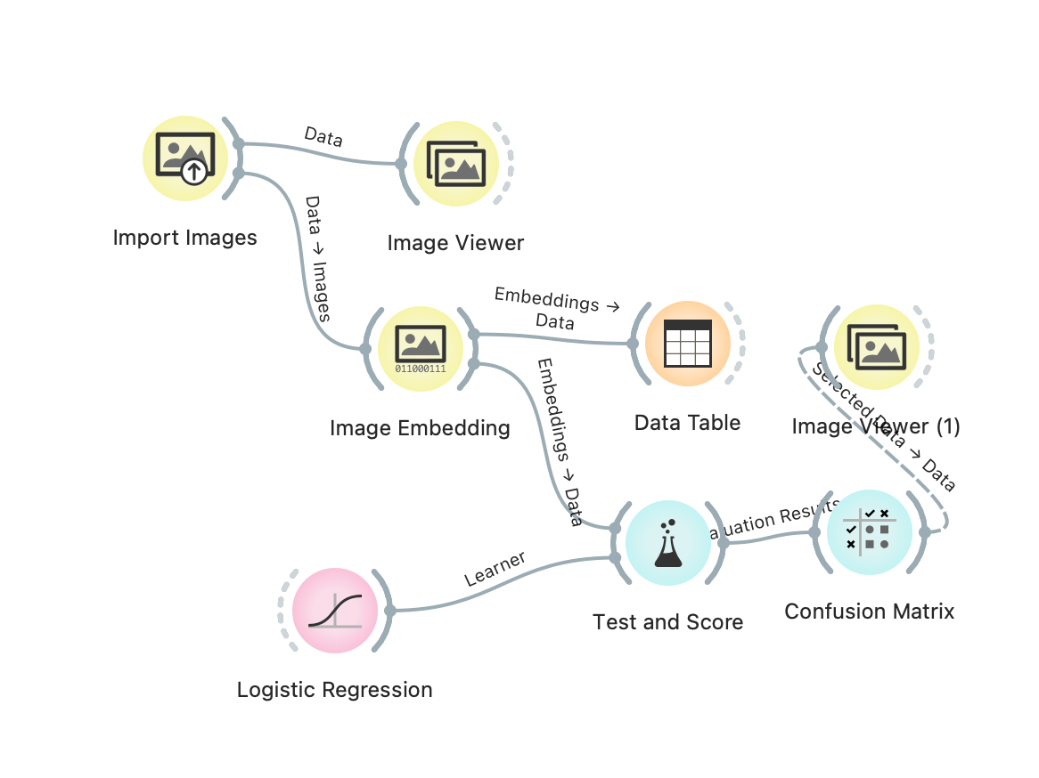

A

**Orange Embedding**

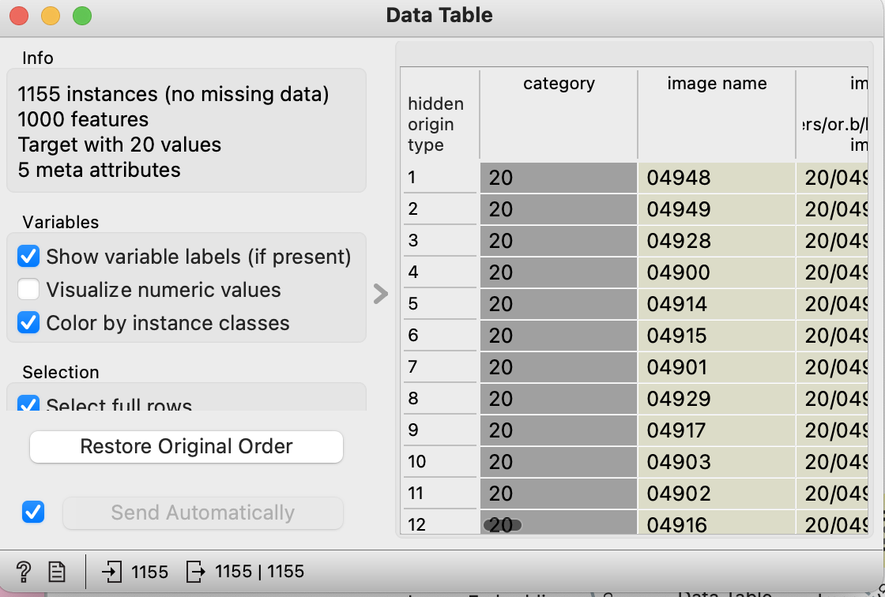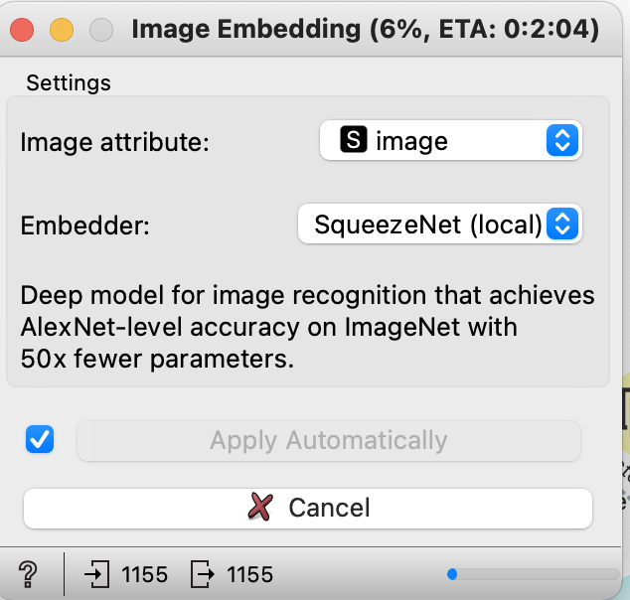

B

Block A is an import images block that reads the images into the orange framework.

Orange default emending is a pre-trained network, SqueezeNet.

The emending block converts the images into a table containing 1000 features (B). Each feature receives a probability that affiliates to a particular group of images.

**Test and Score**

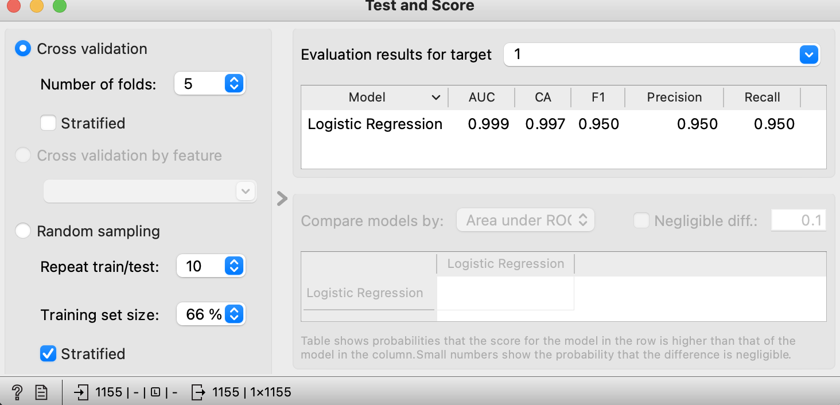

The results are quite high since I used a small number of Images (1155 images). Yet, it provides a good indication of the SqueezeNet.

**Confusion Matrix**

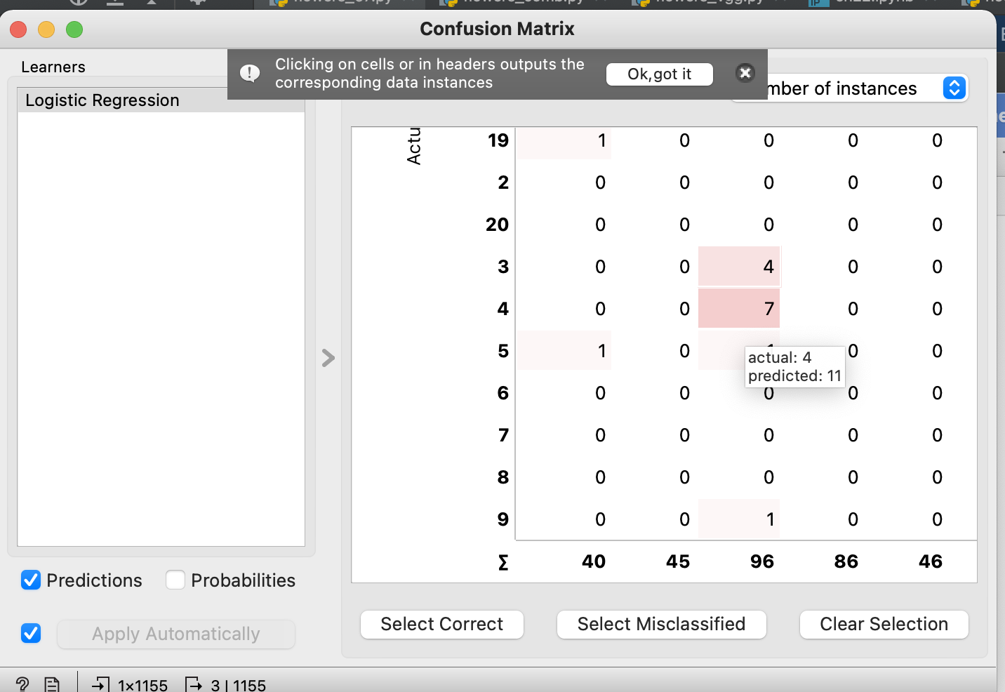

The following example shows that a group of 7 flowers mistakenly belong to category 11, although they belong to category 4.

**Category 4 flowers**

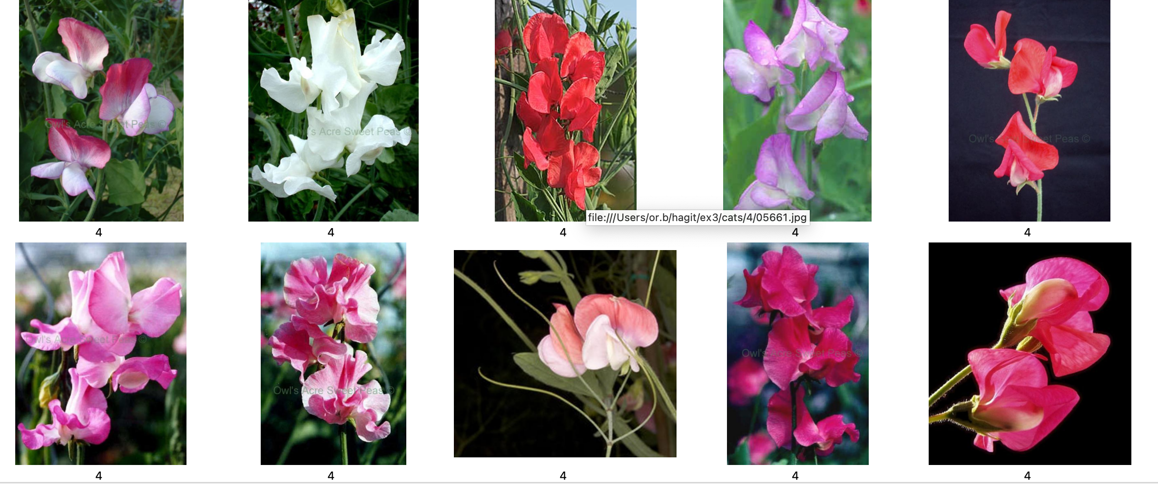

**Category 11 flowers**

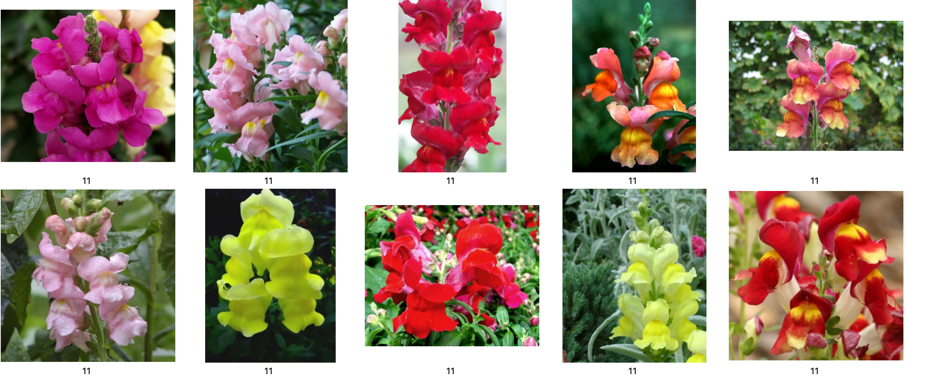

**Confused Flowers (4 -> 11)**

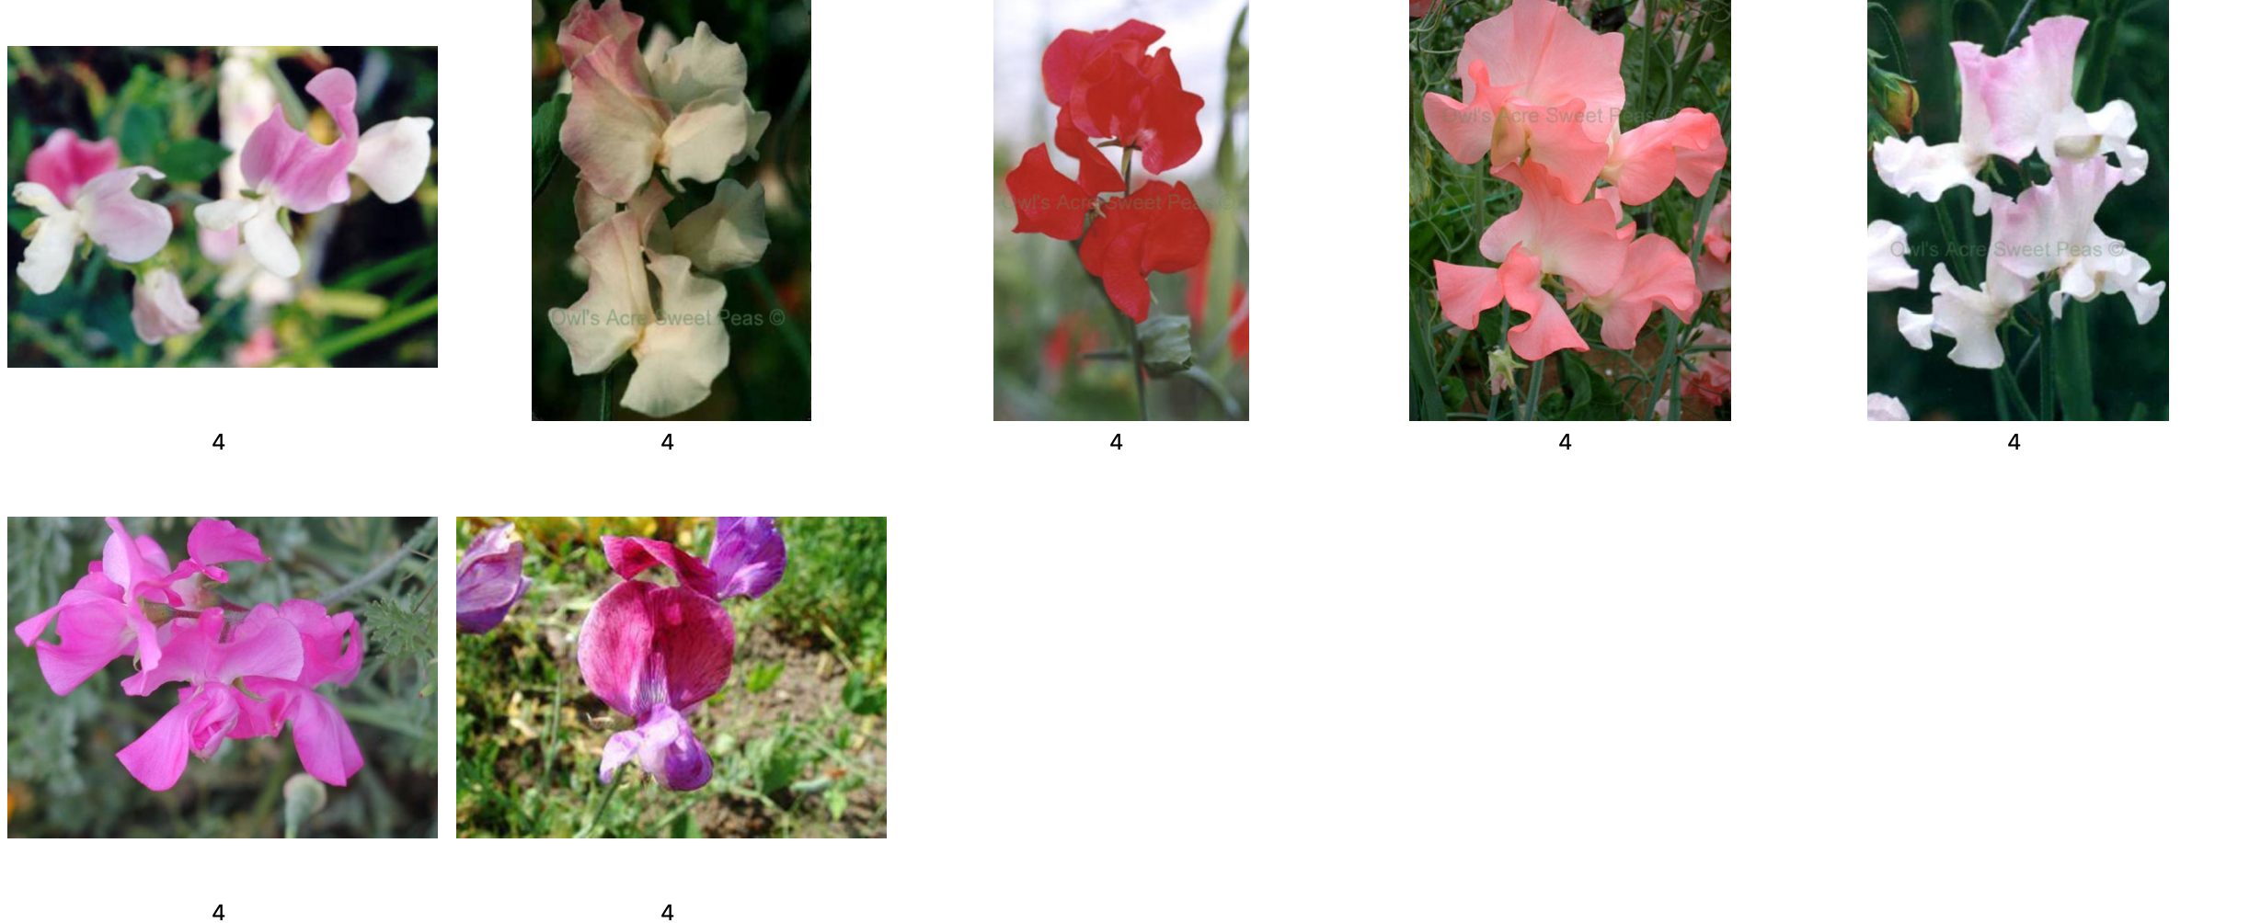

**Confusion Analysis**

For example, the circled flower (in red) is a bit blur. Applying a blur augmentation on the dataset might deal with this issue.

Train, validate and test the whole dataset (102 oxford flowers)

Two pre-trained network were selected – SqueezeNet and MobileNet.

The pre-trained layer were set to non-trainable.

All images were imported and preprocessed using Keras image processing.

The dataset was randomly divided into training (50%), validation (25%) for hyperparameter tuning, and test sets (25%). This random split was repeated twice.

The last layer of each model is a Dense layer at a size of 102 (number of categories in the dataset)

Each fitting set consists of 10 epochs.

**SqueezeNet Learning Graph**

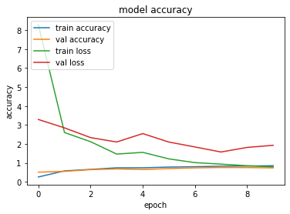

**MobileNet Learning Graph**

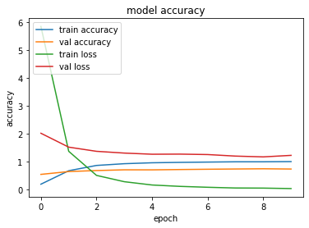

**Results**

**SqueezeNet**

1st run - accuracy of 73.4%

2nd run - - accuracy of 78.6%

**MobileNet**

1st run - - accuracy of 73.09%

2nd run - - accuracy of 74.46%